Alexander Baldree
2/18/26
Module 7.2 Assignment (Biosite)
CSD340

Github Link:
https://github.com/Panda-Alex21687/BioSite
Github.io Link:
https://panda-alex21687.github.io/BioSite/

Output Index:
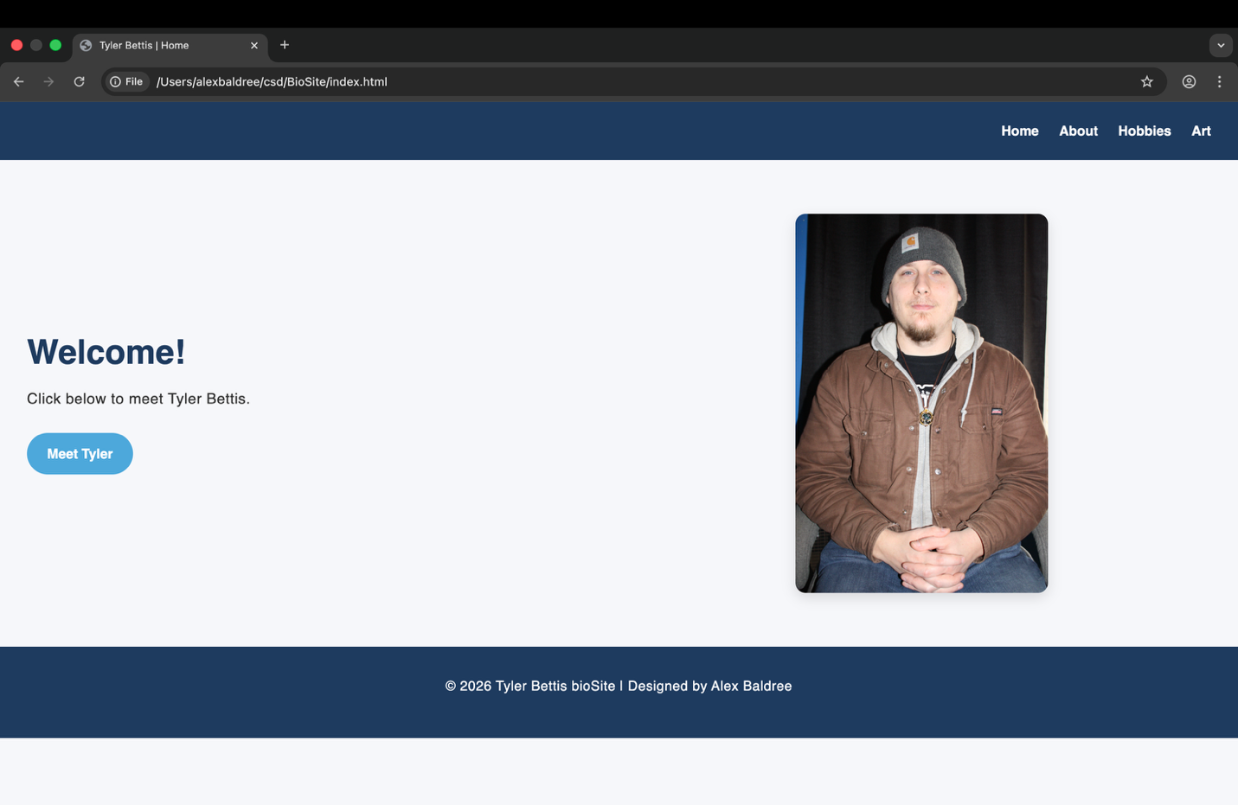

Output About:
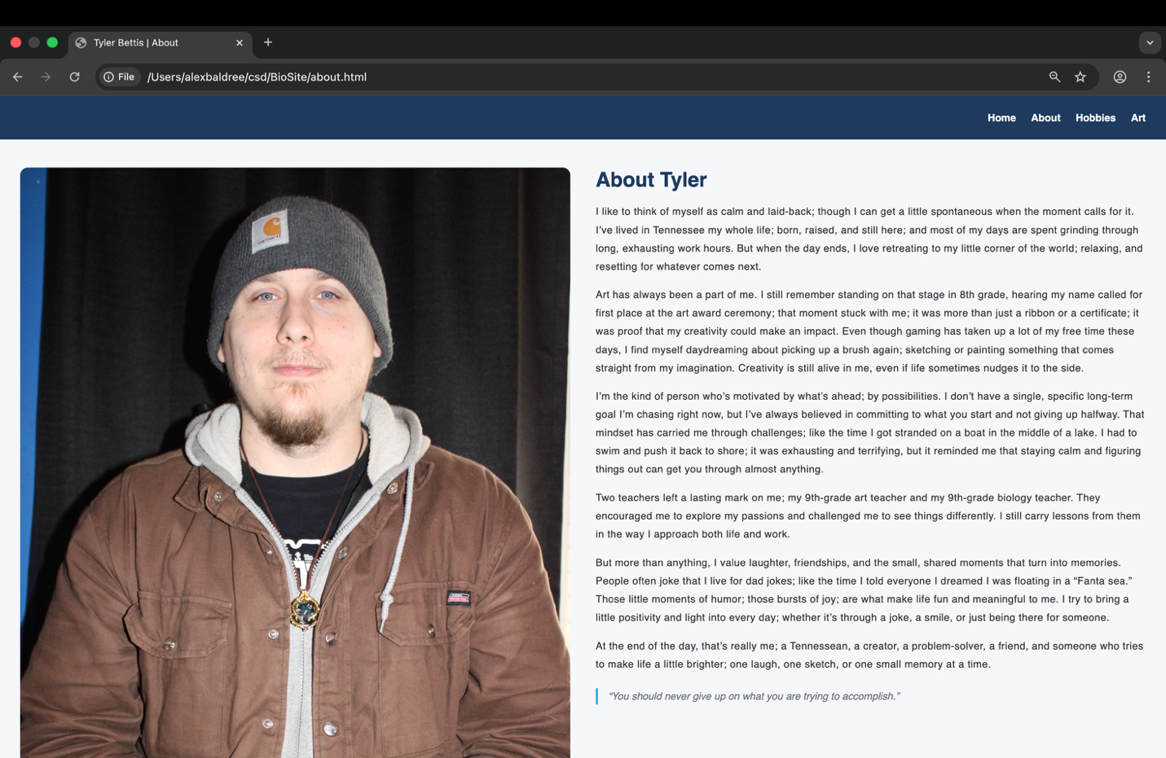

Output Hobbies:
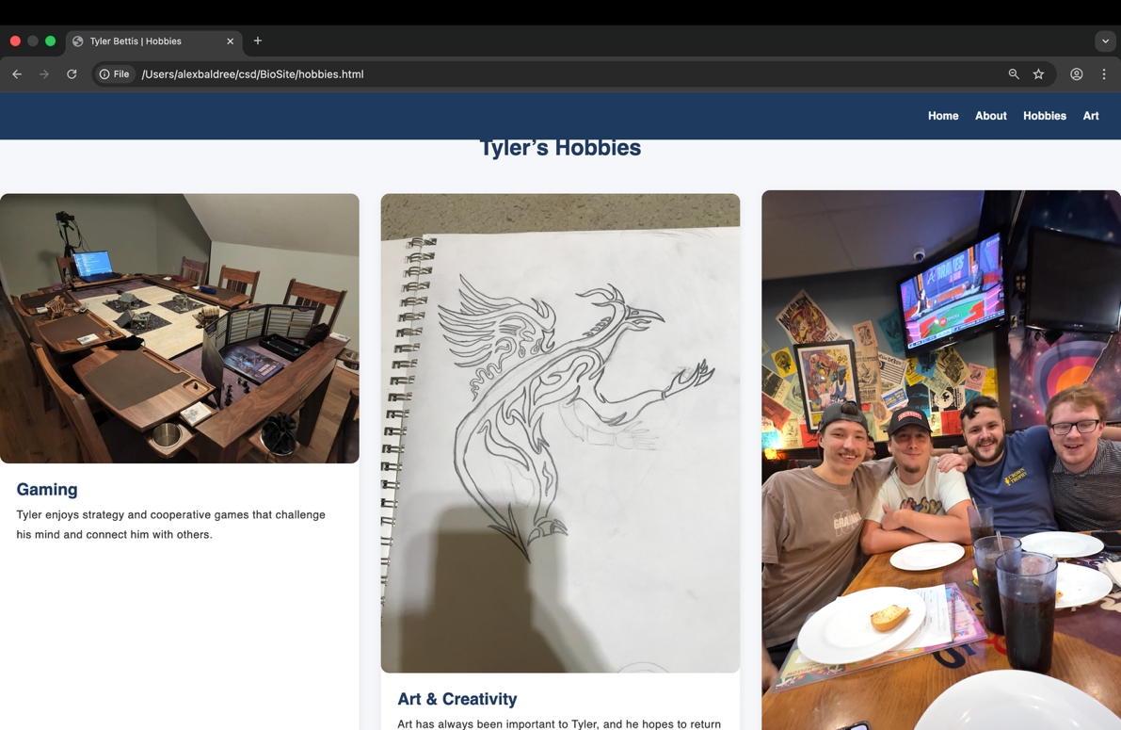

Output Art:
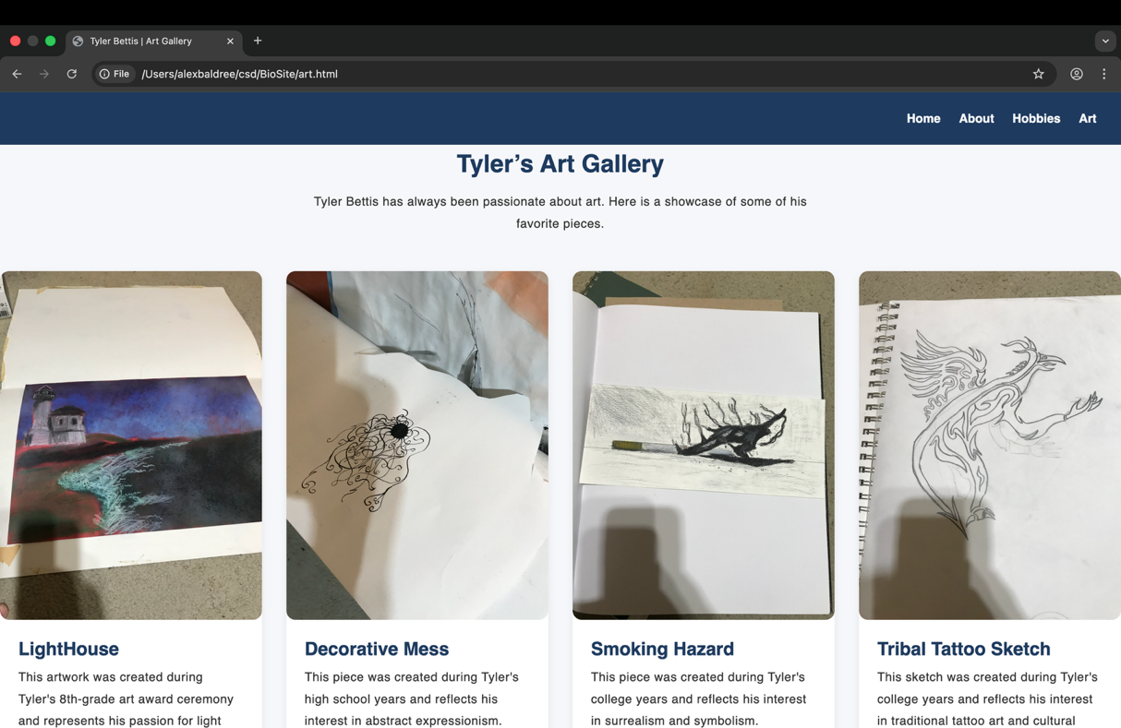

I made an extra tab for art, since he draws a lot and I wanted to showcase his abilities.

